application-new-certification

  - For Private Training Institutions
Applying for Certification for the First Time
This package includes:
- What an institution needs to know before applying for certification.
- The application form and checklist that an institution must complete and submit to apply for certification.
- What an institution needs to know about the first year of operations
as a certified institution.

- what an institution needs to know before applying for covers each step of the process for private training institutions applying for certification with the Private Training Institutions Branch for the first time.

Contents
Section 1: Before you Apply 3
1.1 Do I need a certificate? 3
1.2 Considerations before applying 4
Section 2: Applying for a certificate 6
New Certification Application – Process Overview and Checklist 6
Step 1: Complete an orientation session 7
Step 2: Create a Business BCeID 7
Step 3: Certification Application Form & Required Records 8
3.1 Certification Application Form 8
3.2 Records to submit with the application 16
Step 3.3. Program information to submit with the application 18
Step 4: PTIB confirms whether certification application may proceed 19
5: Institution pays fees 19
Step 6: PTIB reviews materials and schedules pre-certification inspection 20
Step 7: Pre-certification inspection 20
Step 8: Institution to provide security (if required) 21
Step 9: Registrar issues a certificate 21
Section 3: The first year of certification 22
Key Contact at PTIB 22
Deadlines 22
Inspections 22
Operating in Compliance 22

Section 1: Before you Apply

1.1 Do I need a certificate?

Institutions that require a certificate
Private institutions in British Columbia require a certificate if they provide, or offer to provide, at least one career-related program with:
- 40 hours or more of instructional time, and
- Tuition of at least $4,000
This applies to all programs, whether delivered in class or by distance education. These are called Class A programs.
For a list of institutions that the Private Training Act does not apply to, see Section 1.1 of the PTA Policy Manual.

Pathways to certification
Institutions can choose from one of two distinct pathways to certification: registration or designation.
Registration is the minimum requirement for private training institutions offering Class A programs.
Designation is associated with a higher level of quality. Only designated institutions can:
- Apply for the B.C. Education Quality Assurance (EQA) designation and, once EQA is achieved, enrol international students on study permits.
Please note that effective January 2024, the Ministry of Post-Secondary Education and Future Skills has paused all new EQA designations until February 2026. New institutions will not have access to the federal Designated Learning Institutions (DLI) list to recruit international students until the moratorium ends.
Note that a requirement for a designation certificate is that the institution has been continuously certified for the past year. This means that first time applicants do not meet the requirements for a designation certificate. An interim designation certificate may be issued when an institution applies for, but does not meet, all the requirements for designation.
- Apply for StudentAid BC (SABC)

Voluntary designation
Institutions not offering Class A programs may apply for a designation certificate if they offer a Class B or Class C program. They may not apply for a registration certificate.
Class B programs are career-related programs at designated/interim designated institutions, other than Class A programs, for which tuition is at least $1,000.
Class C programs are language programs at designated/interim designated institutions that are longer than six months or for which tuition is at least $4,000. A language program is defined as a program that has as its learning objective that students gain or improve proficiency in a language.

1.2 Considerations before applying
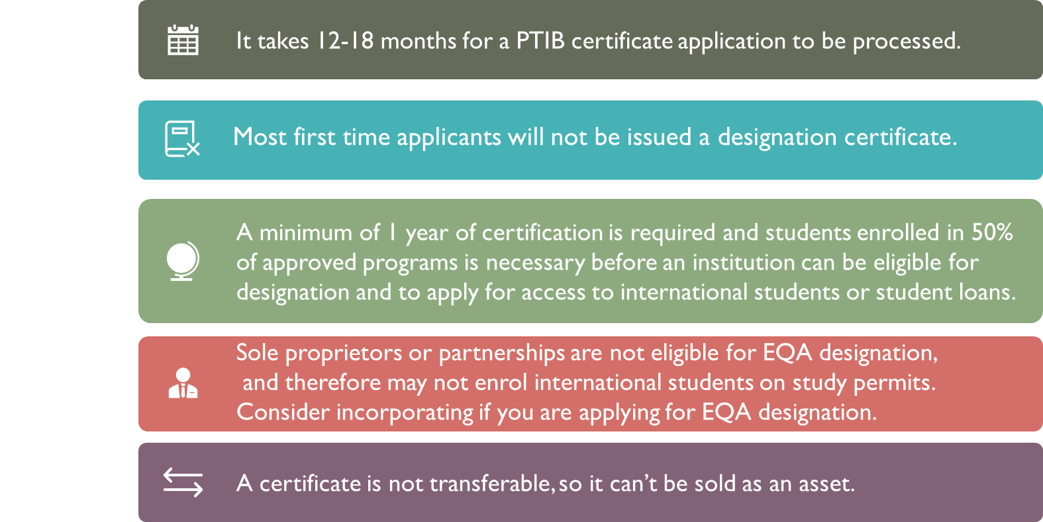
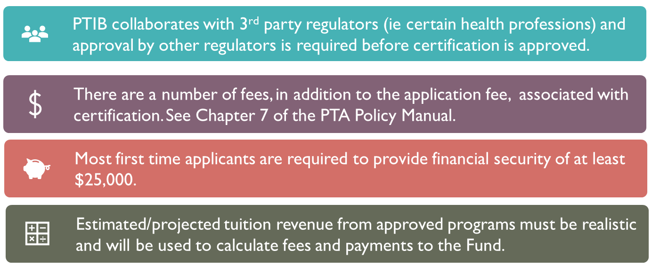
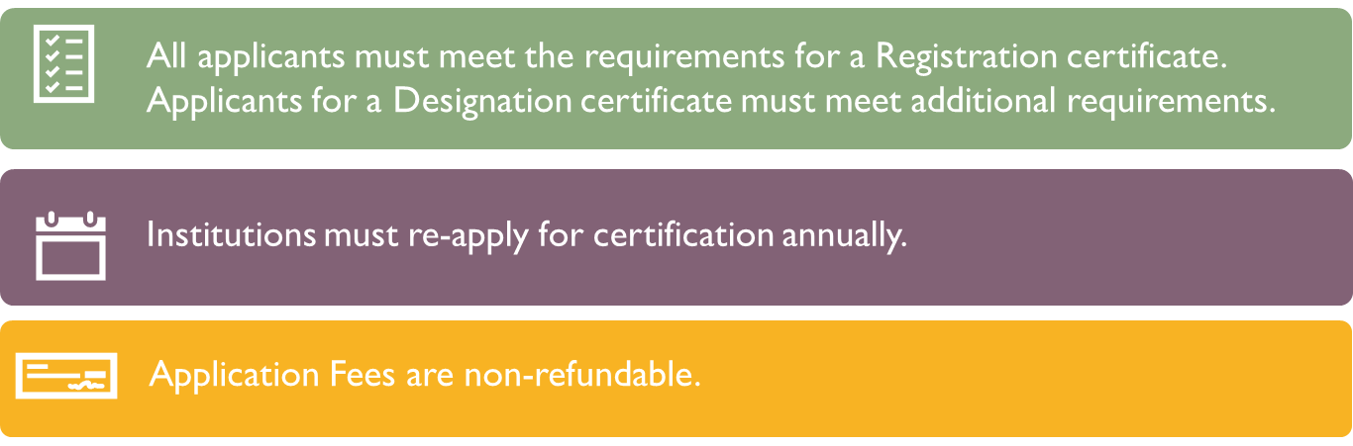

Section 2: Applying for a certificate

New Certification Application – Process Overview and Checklist
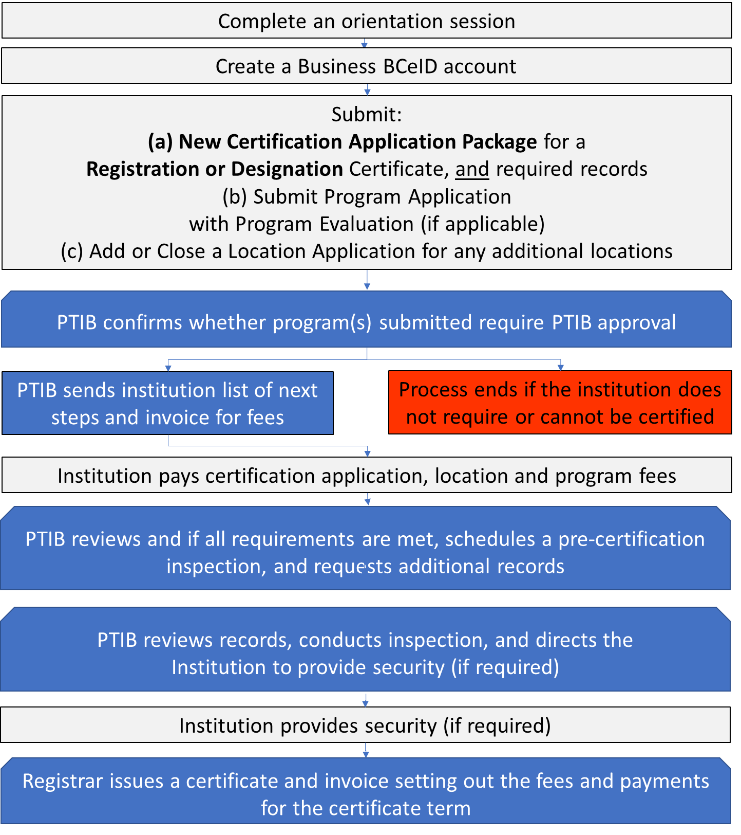
Step 3
Step 6
Step 5
Step 8
Step 9
Step 7
Step 4
Step 2
Step 1

Step 1: Complete an orientation session
It is a requirement for first time applicants for a certificate to attend an orientation session within 6 months of applying for a certificate. The session must be completed by someone legally authorized to act on behalf of the institution, or the Senior Educational Administrator for the institution. The purpose of the orientation sessions is to provide institutions with an overview of the regulatory framework, familiarize institutions with Private Training Act Policy Manual, and help institutions understand who requires a certificate and how to apply.
Institutions may participate in any session either in person or online, however there is a limit to the number of participants that can be accommodated at each session. A waitlist will be established once each session is full. Each session will run from approximately 9:00AM – 12:00PM. For us to accommodate the maximum number of participants, a person can only register for one session. Should a person register for multiple sessions his/her name will remain on the list for the earliest session and be removed from any subsequent sessions.
Institutions are strongly encouraged to review the Starting a Private Training Institution presentation prior to registering for an orientation session.
To register for an orientation session, go to: https://www.privatetraininginstitutions.gov.bc.ca/institutions/orientation-sessions

Step 2: Create a Business BCeID

2. 1 To register for a Business BCeID, go to:
https://www.bceid.ca/register/business/getting_started/getting_started.aspx.

2.2 Enter your BCeID in Step 3.1 Certification Application Form
Once you have created a Business BCeID account, enter your BCeID account information into the Application for New Certification Ensure that you submit the Package, along with the New Program Application, from the email account associated with your BCeID.

Step 3: Certification Application Form & Required Records
Complete the application form below.
Prepare the required records set out in Step 3.2.
Use the Application for Certification Checklist in this package to ensure that you have completed all the requirements as part of Step 3. Incomplete applications will not be processed.
Submit the Application Package along with the Step 3.2 required records to pti@gov.bc.ca.

Certification Application Form
- Institution Information
Certificate application type | Choose certificate Type

Review Section 1 of this Package for information about the different types of certificates.
Institution number (if you have one) | 0000
Legal name | Insert Legal Name
Operating name | Insert Operating Name

Legal and Operating Name
If you want to use an operating name other than your legal business name, you will need to register it as a “doing business as”, or trade name. For more information, go to: https://www.canada.ca/en/services/business/start/choosing-a-business-name-3.html.

Fiscal year ends on (MM/DD) | MM-DD

Fiscal year end
Institutions may choose the last day of any month as their fiscal year end.
Note that certificate expiry and deadlines for reporting are tied to an institution’s fiscal year end.
Once certified, a change in fiscal year will, therefore, have a significant impact and must be reported in writing at least 60 days before the change. It also requires prior approval from Canada Revenue Agency. For more information, go to www.cra-arc.gc.ca/.

Business Type |  | Choose a business type

Business Type
Use the following table to identify your business type and the information required in the application and records required to be submitted with the application for certification for that business type.
Business Type | Required Information to Submit in the Application |  | Required Records to Submit with the Application
Company  (as defined by the Business Corporations Act) | - the name of its major shareholder |  | - a copy of its central securities register  - copy of central securities register of shareholders if shareholders are legal entities  - a certificate of good standing
Extraprovincial company  (as defined by the Business Corporations Act) | - the name of its major shareholder |  | - a copy of its central securities register  - copy of central securities register of shareholders if shareholders are legal entities  - a certificate of good standing
Corporation (other than a company, an extraprovincial company, a society or an extraprovincial non-share corporation)  (as defined by the Business Corporations Act) | - the name of its major shareholder |  | - copy of its central securities register  - copy of central securities register of shareholders if shareholders are legal entities
Partnership  (as defined by the Partnership Act) | - Names of the partners |  | - a signed copy of the partnership agreement
Limited partnership  (as defined by the Partnership Act) | - the names of its general partners |  | - Not applicable
Society or extra provincial non-share corporation  (as defined by the Societies Act) | - the names of its directors (as defined by the Societies Act) |  | - a copy of the most recent annual report filed under filed under section 68 [filing annual report] or 78 [return to registrar] the Societies Act
Sole proprietorship  (as defined as a person who is engaged in the business of operating an institution and who is not associated in partnership with any other person or persons) | - the full name of the proprietor |  | - Sole Proprietorship Statement of Registration
Indigenous institution  (As defined in by the Fees and Student Tuition Protection Fund Regulation) | - the legal name of the entity that operates the institution |  | - not applicable

- Contacts
Institutions must provide the names of certain individuals dependent upon the institution’s business type – see the Business Type table above.
Institutions must also designate:
- A primary contact
- An alternate contact
- PTIB Portal Users
- A Senior Educational Administrator (designation applicants only)
First Name | Enter First Name |  |  | Last Name | Enter Last Name
Honorific appropriate to person |  |  | Ie, Mr, Ms, Dr | Title within institution | Title within institution
Email, phone, and address information is required for contacts whose role is Senior Educational Administrator, Addressee for Service, Alternate Contact, Proprietor, Partner or General Partner
Email address, phone number and BCEID user name are required for contacts whose role is PTIB Portal User. The Information must match the what the institution provided to BCEID when they added the user.
Business Phone Number |  | Enter Business Phone number |  | Alternate Phone Number | Enter Alternate Phone Number
Business Email Address |  | Enter Business Email Address |  | Fax Number | Enter Fax Number
BCEID User Name |  | Enter BCEID User Name
☐ The contact is a legal entity, not a person, that has an interest (such as Shareholder) in the Institution.
Roles fulfilled by this contact
☐ Addressee for service/ ☐ PTIB Portal User Role - ☐ Administrator ☐Basic User
Institution Primary Contact ☐ Institution Alternate Contact (optional)
☐ Sole Proprietor ☐ Shareholder - percentage holding: Enter percentage holding. ☐ Director (only applies to societies)
☐ Partner ☐General Partner (only applicable to Limited Partnerships)
☐ Senior Educational Administrator (designated/interim designated institutions only)

Additional Contacts information 1

Information regarding additional contacts can be added by clicking on the arrow bullets below or be submitted with this application as an attachment.

First Name | Enter First Name |  |  | Last Name | Enter Last Name
Honorific appropriate to person |  |  | Ie, Mr, Ms, Dr | Title within institution | Title within institution
Email, phone, and address information is required for contacts whose role is Senior Educational Administrator, Addressee for Service, Alternate Contact, Proprietor, Partner or General Partner
Email address, phone number and BCEID user name are required for contacts whose role is PTIB Portal User. The Information must match the what the institution provided to BCEID when they added the user.
Business Phone Number |  | Enter Business Phone number |  | Alternate Phone Number | Enter Alternate Phone Number
Business Email Address |  | Enter Business Email Address |  | Fax Number | Enter Fax Number
BCEID User Name |  | Enter BCEID User Name
☐ The contact is a legal entity, not a person, that has an interest (such as Shareholder) in the Institution.
Roles fulfilled by this contact
☐ Addressee for Service / ☐ PTIB Portal User Role - ☐ Administrator ☐Basic User
Institution Primary Contact ☐ Institution Alternate Contact (optional)
☐ Sole Proprietor ☐ Shareholder - percentage holding: Enter percentage holding.
☐ Senior Officer ☐ Director
☐ Partner ☐General Partner (only applicable to Limited Partnerships)
☐ Senior Educational Administrator (designated/interim designated institutions only)

Additional Contacts information 2
First Name | Enter First Name |  |  | Last Name | Enter Last Name
Honorific appropriate to person |  |  | Ie, Mr, Ms, Dr | Title within institution | Title within institution
Email, phone, and address information is required for contacts whose role is Senior Educational Administrator, Addressee for Service, Alternate Contact, Proprietor, Partner or General Partner
Email address, phone number and BCEID user name are required for contacts whose role is PTIB Portal User. The Information must match the what the institution provided to BCEID when they added the user.
Business Phone Number |  | Enter Business Phone number |  | Alternate Phone Number | Enter Alternate Phone Number
Business Email Address |  | Enter Business Email Address |  | Fax Number | Enter Fax Number
BCEID User Name |  | Enter BCEID User Name
☐ The contact is a legal entity, not a person, that has an interest (such as Shareholder) in the Institution.
Roles fulfilled by this contact
☐ Addressee for Service / ☐ PTIB Portal User Role - ☐ Administrator ☐Basic User
Institution Primary Contact ☐ Institution Alternate Contact (optional)
☐ Sole Proprietor ☐ Shareholder - percentage holding: Enter percentage holding.
☐ Senior Officer ☐ Director
☐ Partner ☐General Partner (only applicable to Limited Partnerships)
☐ Senior Educational Administrator (designated/interim designated institutions only)

Additional Contacts information 3
First Name | Enter First Name |  |  | Last Name | Enter Last Name
Honorific appropriate to person |  |  | Ie, Mr, Ms, Dr | Title within institution | Title within institution
Email, phone, and address information is required for contacts whose role is Senior Educational Administrator, Addressee for Service, Alternate Contact, Proprietor, Partner or General Partner
Email address, phone number and BCEID user name are required for contacts whose role is PTIB Portal User. The Information must match the what the institution provided to BCEID when they added the user.
Business Phone Number |  | Enter Business Phone number |  | Alternate Phone Number | Enter Alternate Phone Number
Business Email Address |  | Enter Business Email Address |  | Fax Number | Enter Fax Number
BCEID User Name |  | Enter BCEID User Name
☐ The contact is a legal entity, not a person, that has an interest (such as Shareholder) in the Institution.
Roles fulfilled by this contact
☐ Addressee for Service / ☐ PTIB Portal User Role - ☐ Administrator ☐Basic User
Institution Primary Contact ☐ Institution Alternate Contact (optional)
☐ Sole Proprietor ☐ Shareholder - percentage holding: Enter percentage holding.
☐ Senior Officer ☐ Director
☐ Partner ☐General Partner (only applicable to Limited Partnerships)
☐ Senior Educational Administrator (designated/interim designated institutions only)

Additional Contacts information 4
First Name | Enter First Name |  |  | Last Name | Enter Last Name
Honorific appropriate to person |  |  | Ie, Mr, Ms, Dr | Title within institution | Title within institution
Email, phone, and address information is required for contacts whose role is Senior Educational Administrator, Addressee for Service, Alternate Contact, Proprietor, Partner or General Partner
Email address, phone number and BCEID user name are required for contacts whose role is PTIB Portal User. The Information must match the what the institution provided to BCEID when they added the user.
Business Phone Number |  | Enter Business Phone number |  | Alternate Phone Number | Enter Alternate Phone Number
Business Email Address |  | Enter Business Email Address |  | Fax Number | Enter Fax Number
BCEID User Name |  | Enter BCEID User Name
☐ The contact is a legal entity, not a person, that has an interest (such as Shareholder) in the Institution.
Roles fulfilled by this contact
☐ Addressee for Service / ☐ PTIB Portal User Role - ☐ Administrator ☐Basic User
Institution Primary Contact ☐ Institution Alternate Contact (optional)
☐ Sole Proprietor ☐ Shareholder - percentage holding: Enter percentage holding.
☐ Senior Officer ☐ Director
☐ Partner ☐General Partner (only applicable to Limited Partnerships)
☐ Senior Educational Administrator (designated/interim designated institutions only)

Additional Contacts information 5
First Name | Enter First Name |  |  | Last Name | Enter Last Name
Honorific appropriate to person |  |  | Ie, Mr, Ms, Dr | Title within institution | Title within institution
Email, phone, and address information is required for contacts whose role is Senior Educational Administrator, Addressee for Service, Alternate Contact, Proprietor, Partner or General Partner
Email address, phone number and BCEID user name are required for contacts whose role is PTIB Portal User. The Information must match the what the institution provided to BCEID when they added the user.
Business Phone Number |  | Enter Business Phone number |  | Alternate Phone Number | Enter Alternate Phone Number
Business Email Address |  | Enter Business Email Address |  | Fax Number | Enter Fax Number
BCEID User Name |  | Enter BCEID User Name
☐ The contact is a legal entity, not a person, that has an interest (such as Shareholder) in the Institution.
Roles fulfilled by this contact
☐ Addressee for Service / ☐ PTIB Portal User Role - ☐ Administrator ☐Basic User
Institution Primary Contact ☐ Institution Alternate Contact (optional)
☐ Sole Proprietor ☐ Shareholder - percentage holding: Enter percentage holding.
☐ Senior Officer ☐ Director
☐ Partner ☐General Partner (only applicable to Limited Partnerships)
☐ Senior Educational Administrator (designated/interim designated institutions only)

- Class of Institution (select one, if applicable)
Institutions should indicate whether they believe they fall into one of the three classes of institution. If applying to be in a class, submit the required supporting documentation with this application. PTIB will make the final assessment as to whether the institution meet the criteria for an institution class.
☐ Regulatory Body Institution Class: All approved programs lead to employment in a career occupation regulated by Transport Canada or a regulator under the Health Professions Act.
An Institution that has all programs approved by a Regulatory Body must attach documentary proof of approval from that Body (for example, a Transport Canada Certificate, or an approval letter from a regulator such as the BC College of Nurse and Midwives).
☐ Language Institution Class: All approved programs are language programs assessed by an independent body or career-related programs in language instruction.
An institution that has had a program reviewed by an independent agency must attach a copy of the report (for example, an Orion Report for Languages Canada member institutions).
☐ Indigenous Institution Class: Institution operated by a First Nation or Indigenous Society / Corporation.
An institution that is operated by a First Nation or Aboriginal Society / Corporation must provide confirmation from operating organization (for example, a certificate from the BC Registry).

- Website
A website is not a requirement to submit an application. The web address must be provided prior to the pre-certification inspection (Step 8).
Enter website URL

The institutions’ website must comply with the compliance standards set out in the Private Training Regulation. For a list of the standards, see Section 3.2.5 of the Private Training Act Policy Manual.

- Location information
Institutions must provide information about each location from which the institution intends to offer training; this includes locations from which an institution intends to offer a program that does not require approval. For more information about programs that do not require approval, see Section 2.2 of the PTA Policy Manual.
In addition to the registration or designation application fee, an additional location fee of $500 is required for each additional location where an institution provides an approved program. An additional location fee of $200 is required for each additional location where an institution only provides programs not requiring approval.

To apply to offer training from an additional location, complete an Add or Close a Location Application Form available on the Forms, Templates and Resources page of the PTIB website.

PTIB will inspect all institution locations prior to issuing a certificate. For more about inspections, see Step 7.
Street address line 1 |  | Click or tap to enter street address
Street address line 2 |  | Click or tap to enter street address
City | Enter name of City |  | Province | Enter Province |  |  | Postal Code |  | Enter Postal Code
Email address |  |  | Enter email address
Phone number |  | Enter phone number |  |  | Fax number for the address |  |  |  | Enter fax number
Purpose of location  (check all that apply) |  |  | ☐ In-class instruction  ☐ Distance education  ☐ Address for Service (only one per institution)
Maximum occupant load (the maximum number of persons for which a building or part thereof is designed as defined by the B.C. Fire Code) |  |  |  |  |  |  |  | Enter occupant load.
Planned effective date of location |  |  |  | Enter planned effective date.

You must provide a copy of your floor plans and photographs of the physical space to demonstrate that the facilities and space are appropriate for the programs and class sizes you intend to provide.

You must provide a copy of your business license, if your institution is required to hold a business license issued by a local government. If your license has not yet been issued, provide a copy of the license application. The license or application may be provided, at the latest, at the time of the pre-certification.

The business license should indicate that the location is approved for educational activity.

If a license is not required, please explain why not and attach evidence, specifically written notice from the licensing office of the jurisdiction. |  |  |  |  |  | Enter explanation, if applicable.
Shared Space
If you will share this space, please provide the following information for each other occupant:
Occupant name | Enter Occupant’s name.
Nature of Occupant’s business | Enter nature of Occupant’s business.
Occupant name | Enter Occupant’s name.
Nature of Occupant’s business | Enter nature of Occupant’s business.
If another occupant also provides career training or other instruction, please explain how you will ensure it is clear to all students at all times who is providing their instruction and to whom they should go regarding administrative issues and concerns.
Enter information requested above, if applicable.

- Student Records Archiving Vendor
Vendor | Choose vendor from drop down menu
Institutions offering Class A programs other than programs of instruction that lead to employment in a career occupation regulated by Transport Canada, the federal regulator, must enter into an agreement with Cube Global or Datawitness, approved archiving vendors, which stipulates that:
- Student records must be archived in a secure manner for 25 years from the date the record is provided to the third party, and
- The registrar must have access to the records on request.

For more about archiving student records, see Section 3.2.10 of the Private Training Act Policy Manual. Compliance standards include that an institution must provide the archived student record to the approved archiving vendor within 60 days of:
- The end date of the student enrolment contract, or
- The date the institution receives a notice of withdrawal, or
- The date the institution delivers to the student a notice of dismissal.

Institutions offering solely language programs are exempt from this requirement.

- Declarations
Please complete this page and print, sign, and include it with your application.

Has the institution, or an associated institution within the meaning of section 46 [associated institutions] of the Private Training Act, suspended operations in any jurisdiction, or been closed or involved in an action in any jurisdiction respecting the closure of the institution? | Choose an item

I have reviewed the New Certification Application Checklist and confirm that this form includes the information required to support our application for:
Choose an item.

Please complete the Declarations section and submit it with your application. Electronic signatures will be accepted if this form is submitted by email by the institution’s primary or alternate contact.
☐ I confirm I have the legal authority to act on behalf of the institution.
☐ I confirm all the information contained in this application and any attachment is true, accurate and complete.
Personal information may be collected by the Ministry of Post-Secondary Education and Future Skills under section 61 of the Private Training Act and section 26 (a) and (c) of the Freedom of Information and Protection of Privacy Act (FOIPPA). Personal information will be collected, used and disclosed as necessary to assess the submission. If you have any questions about the collection disclosure and use of this personal information, you may contact Director, Policy and Institution Certification, Private Training Institutions Branch, Ministry of Post-Secondary Education and Future Skills, 203-1155 W. Pender St. Vancouver V6E 2P4, 1-800-661-7441.
☐ I am authorized to submit personal information about others that is necessary to complete this form.
Authorized By |  |  | Authorized title: | Enter title
 | Signature. Must be signed |  | Print name |  | Date signed  Select date
Send completed applications and required attachments to pti@gov.bc.ca.
PTIB will not accept submissions with links to files saved to external document storage services (i.e. Google Drive).
Ensure that you submit at least one New Program Application (Class A, B or C) with this Application for New Certification.
If the contents outlined in the application form are not compliant with requirements defined in the Private Training Act (PTA) and Private Training Regulation (PTR), the application may be denied by the registrar.

- Application – New Certification Checklist
☐ Attend an Orientation | Date of Orientation: YYYY-MM-DD | Passcode: Enter passcode.
☐ Application – New Certification (completed and signed)
☐ Business Plan
☐ General Liability Insurance
☐ Legal Entity Documents (check individual items)
☐Certificate of Registration of Sole Proprietorship ☐ Partnership Agreement
☐ Society Annual Report ☐ Certificate of Good Standing (company/corporation/extraprovincial)
☐ Central Securities Register for the legal entity (company/corporation/extraprovincial)
☐ Central Securities Register for the legal entity’s shareholder (company/corporation/extraprovincial)
☒ Institution Class supporting documents (☐ Transport Canada programs ☐ All language programs)
OR
☐ N/A
☐ Copy of Archiving Agreements ☐ Datawitness ☐ CubeGlobal
OR
☐ Archiving not applicable
☐ No Class A programs ☐ Only intends to offer Language or Transport Canada training programs
☐ Student Enrolment Contracts ☐Approved programs ☐ Approval Not Required programs
☐ Student Policies
☐ Dispute Resolution ☐ Dismissal ☐ Grade Appeal ☐ Attendance ☐ Tuition Refund
☐ Sexual Misconduct ☐ Respectful & Fair Treatment of Students ☐ Statement of Student Rights
☐ Business License ☐ N/A – Supporting documents for exemption
☐ Copy of floor plan for the location ☐ Photographs of physical space
☐ Location Application form for additional location
☐ Copy of floor plan for the location ☐ Photographs of physical space
☐ Program application form for an approved program ☐ Number of programs ___
☐ Program application form for approved not required program ☐ Number of programs __
☐ Program Outlines ☐ Course Outlines
☐ Work Experience requirements ☐ N/A – no work experience
☐ Work experience policy ☐ Copy of Host agreement ☐ List and info on host organization
See next page for additional requirements for application for Designation
Additional requirements for application for Designation
☐ Comprehensive Resume of Senior Educational Administrator
☐ Copies of Adult Education Credential(s)
Additional requirements for application for Designation (Class A programs)
☐ Program Evaluation Report (prepared by qualified program evaluator) submitted by the evaluator directly to PTIB on: Click or tap to enter a date. Name of Evaluator: Enter name of Evaluator.

3.2 Records to submit with the application
- Business Plan
Institutions applying for a certificate for the first time must submit a business plan that includes the following elements:
- Industry/market analysis
- Marketing plan
- Financial plan
The estimate of tuition revenue from approved programs provided in the business plan must be realistic as it will be used to assess fees and payments to the Student Tuition Protection Fund owing if PTIB issues a certificate. There is no reassessment should the institution not meet the estimated amount.
The template for the Business Plan can be found in on the Forms, Templates and Resources page.
- Legal entity documents
Certain business types must submit specific records with their application. For a list of these requirements, see the Business Type section.
- Institution Class Records
If the institution has indicated in the New Certification Application that it is in an Institution Class, provide the required supporting records.
- Resume of Senior Education Administrator (only if applying for designation)
An institution must have a Senior Educational Administrator (SEA) who holds a degree, diploma, certificate or comparable education or work experience in adult education. The SEA is responsible for:
- Ensuring that, for each approved program, the course outline(s), curriculum and program outline are relevant to the learning objectives of the program
- Overseeing a performance evaluation process for instructors
Attach a detailed resume and copies of the credential that substantiates this.
- Submit student enrolment contracts
Institution must submit copies of both student enrolment contracts used by the institution for approved programs and for programs that do not require approval.
Templates are available on the Forms, Templates and Resources page:
- Student Enrolment Contract – Approved Program – Sample
- Student Enrolment Contract - Program that Does Not Require Approval - Sample

Institutions are required to sign a written contract with each student they enrol, unless the program is employer provided (meaning all students enrolled are funded by a single employer or third party). This applies to approved programs and programs not requiring approval.

Institutions are required to sign a written contract with each student they enrol, on or before the program start date, unless the program is employer provided (meaning all students enrolled are funded by a single employer or third party). This applies to approved programs and programs not requiring approval.
The student enrolment contract must set out accurate information about the program. Institutions must enter a written student enrolment contract with every student on or before the start date of their program. The institution must provide the student a copy of the signed enrolment contract as soon as practicable.

Contracts for approved programs must:
- Be written in a clear and comprehensible manner in not less than 10-point type
- Be for a term no longer than 18 months. If the program is longer than 18 months, a subsequent student enrolment contract can only be signed after 30% of the program’s hours of instruction listed in the original contract have been provided.
- Include all required information (see Appendix 11 of the Private Training Act Policy Manual)
The contract must be dated and signed by:
  - The student or, if the student is under the age of 19, by a parent or legal guardian
  - An individual who has legal authority to act on behalf of the institution
Contracts for programs that do not require approval must include:
  - The start date of the program
  - The amount of tuition and related fees for the program
  - The refund policy. If there is no refund, the contract should make that clear.
- The following statement: “This program does not require approval by the Private Training Institutions Branch (PTIB) of the Ministry of Post-Secondary Education and Future Skills. As such, PTIB did not review this program. Students may not file a claim against the Student Tuition Protection Fund in relation to this program.”
- Submit the student policies
All institutions must have written student policies that meet the standards specified this section. The Institution must provide copies of the policies to students before the start of the program.

Institutions must submit to PTIB the following policies:
- Dispute Resolution Policy

These standards apply to all approved programs.

- Student Dismissal Policy
- Student Grade Appeal Policy
- Respectful and Fair Treatment of Students Policy
- Student Attendance Policy
- Sexual Misconduct Policy
In addition, the Tuition Refund Policy must be submitted to PTIB as it is a required component of enrolment contracts for programs requiring approval.

The compliance standards for student policies are set out in Section 3.2.1 of the Private Training Act Policy Manual.

Templates for all mandatory student policies are available on the PTIB website at https://www.privatetraininginstitutions.gov.bc.ca/form-library.

- Business License
You must provide a copy of your business license, if your institution holds a business license issued by a local government. This requirement is applicable for all institutions, including those planning to offer distance programs exclusively.
- General Liability Insurance
The institution must submit evidence that it has obtained general liability insurance in order to be certified. An institution may apply for certification before obtaining general liability insurance, however evidence of insurance must be submitted before the registrar will issue a certificate.

Step 3.3. Program information to submit with the application
3.3.1 Submit new program applications for all programs

An Application – New Program must be submitted at the same time as the New Certification Application Package.

Submit an application for each new program, whether the program requires approval or is a program that does not require approval.
For new programs that require approval, use the Application – New Program form.
To request confirmation of whether a new program requires approval, including programs that you believe do not require approval, use the Request for Confirmation of Program Class form.
Application forms are available on the Forms, Templates and Resources page of the PTIB website. Email the completed application along with all required records set out in Appendix 4 of the PTA Policy Manual to PTI@gov.bc.ca.
To be certified, institutions must offer at least one program that requires PTIB approval. See Section 1.1: Do I need a certificate of this package for information about programs that require approval.

3.3.2 Identify a program evaluator (if required)
Designated/interim designated institutions applying for approval of a Class A program must submit a program evaluation unless the registrar has informed the institution that an evaluation, or certain elements of the evaluation, is not required (see “Program Evaluations” for more information).
Institutions may find potential evaluators through professional associations, business networking, regulators, other institutions (public or private), members of their program advisory committee, etc. Also, the PTIB website provides a list of people with subject matter expertise in a variety of fields: https://www.privatetraininginstitutions.gov.bc.ca/institutions/subject-matter-experts. Institutions may contact them directly to see whether they wish to take on an evaluation. A program evaluator should meet the minimum instructor qualifications appropriate for the program (vocational, academic or language). See Private Training Act Policy Manual s.3.2.8 for reference.

It is the institution’s responsibility to ensure that the evaluator has the appropriate background. If an evaluation report is not completed by an appropriate PE the registrar may, at her discretion, decline to accept it as meeting the requirement and require an entirely new report. The registrar may also deny the application and require the institution to start over. If you are in doubt about whether an evaluator is suitable, we recommend you continue your search.
Resources:
- Guidelines for Subject Matter Experts and Program Evaluators
- Program Evaluation Report Template
The registrar will assess whether each program requires approval and, if so, the class it is in. For details on the information and records required, see Appendix 4 of PTA Policy Manual.
Pay any applicable fees. See Section 2.5 of the PTA Policy Manual for more information.
Step 4: PTIB confirms whether certification application may proceed
Program Evaluations
A new program evaluation is a required part of an application for a Class A program submitted by a designated/ interim designated institution, or by an applicant for a designation certificate. It may also be required, at the registrar’s discretion, for any other new program or program change requiring approval.
The program evaluation is an important tool that provides the registrar an unbiased opinion about the program submitted for approval.
The registrar may waive the requirement for a program evaluation or elements of that evaluation for a new program application. Requests to waive a program evaluation must be made in advance of application submission. An application submitted without a program evaluation, unless previously waived, will be considered incomplete and will not be accepted for review. Send requests to waive an evaluation to PTI@gov.bc.ca. Include your rationale for requesting the waiver.
Generally, applications for new Class A programs at designated/interim designated institutions, and institutions applying for designation, will require a full program evaluation including an in-person site visit by the evaluator with the submission of a program application. The complete evaluation report must be sent directly to PTIB by the program evaluator (PE). Where appropriate, the PE may choose to include photographs or other documentation with their report. The report should be emailed as an attachment and sent to PTI@gov.bc.ca.
For more information about program evaluations including hiring a program evaluator and when the registrar may waive the requirement for a program evaluation, see Appendix 10: New Program Evaluation Guide in the PTA Policy Manual.
The program evaluation must include sufficient analysis. Program evaluations with no or insufficient analysis will not be accepted.
For more information, including a list of subject matter experts (SMEs) who have experience working with PTIB and certified institutions, go to https://www.privatetraininginstitutions.gov.bc.ca/institutions/subject-matter-experts.

4.1 PTIB staff will confirm that the application and all required records and information have been submitted.
Applications will not be reviewed if any required documents or information are missing. PTIB will contact the institution if materials are missing, however, to ensure that your application is assessed as quickly as possible, ensure that all materials have been provided.

4.2 PTIB confirms whether programs submitted require or are eligible for approval
As per section 1.1, institutions must offer at least one program that requires approval in order to be certified. If upon review of the submitted materials the registrar determines that the institution does not require a program that requires approval, PTIB will notify the institution that the application may not proceed.
If the registrar confirms that the institution offers that a program requires approval and that the applications materials provided are complete, PTIB will invoice the institution for required fees and direct the institution to follow the steps set out in Part 3.

5: Institution pays fees
PTIB will issue the institution an invoice for the following fees as applicable:
Fee | Amount | Notes
Registration Application Fee | $3,300
Designation Application Fee | $3,300
Registration certificate application by an institution that holds a designation/interim designation certificate | $500
Designation certificate application by an institution that holds a registration certificate | $500
Change of location from which an institution provides an approved program (includes adding a location) | $500 | Required for each additional location where an institution operates.
Change of location from which an institution only provides programs not requiring approval (includes adding a location) | $200
New Program Application Fees
- Class A program | $900 | Fee is charged per program application.
- Class B program | $500
- Class C program | $500
- Approval not required | $150
Application fees are not refundable.

Step 6: PTIB reviews materials and schedules pre-certification inspection
If all requirements are met, PTIB will request any required additional records and information, and schedule a pre-certification inspection.

Step 7: Pre-certification inspection
PTIB will inspect the locations from where the institution will offer programs.
These inspections are conducted by PTIB staff and/or subject matter experts (SMEs) appointed as inspectors by the registrar.
These inspections are conducted to validate the information provided with an institution’s application for certification, including information related to the program and certification application. Be prepared for inspectors to:
  - Tour the facilities and take photographs
  - Request information from staff
  - Examine, remove or copy existing records
  - Review program information and required policies
  - Discuss regulatory requirements and compliance standards

If you plan to offer online or combined delivery programs, inspectors may also review:
- Pre-recorded lectures
- Microsoft PowerPoint presentations
- Streaming video platforms, and
- Other collaborative tools.
Prepare for your pre-certification inspection by:
- Ensuring your equipment and facilities are available and ready for the delivery of your programs
- Ensuring you have all required policies in place once your institution becomes certified (Attendance, Refund, Dismissal, Grade Appeal, Dispute Resolution, Respectful and Fair Treatment of Students, Work Experience, and Sexual Misconduct policy templates are available on the PTIB website)
- Familiarizing yourself with the Private Training Act (PTA), regulations and the PTA Policy Manual
- Understanding what is required of your institution once you are certified
After the inspection PTIB will notify you of any additional required documents or information.

Step 8: Institution to provide security (if required)
The registrar will assess the application and, if applicable, require the institution to provide security. Most first-time applicants are required to post financial security of at least $25,000.
For more on security, see Chapter 8 of the Private Training Act Policy Manual.

Step 9: Registrar issues a certificate
Once the institution has met the requirements for a certificate the registrar will issue a certificate for each location of the institution. Certificates are generally issued for one year, however an institution’s first certificate may be for shorter or longer than 12 months, depending on the approval date and fiscal year end of the institution.
The certificate must be printed and prominently displayed at each location for which a certificate was issued. Certificates must remain posted until they expire or are surrendered or cancelled.
Along with their certificate(s), the institution will receive an invoice, setting out the fees and payments for the certificate term. These will include:
- Flat rate fees
- Graduated fees
- Payments to the Student Tuition Protection Fund (the Fund)
For more on fees and payments to the Fund, see Chapter 7.

Section 3: The first year of certification

Key Contact at PTIB
The institution will be assigned a PTIB Regulatory Administrator (RA). The RA will be your first point of contact at PTIB.

Deadlines
Institutions wishing to continue to operate must apply for re-certification annually at least 60 days before the expiry date on the institution’s certificate. They must also submit a Student Data Report and provide Financial Statements for the previous fiscal year.

An example re-certification timeline is provided below. Review Chapter 5 of the PTA Policy Manual for a full understanding of the recertification requirements.
Fiscal Year End
Certificate
Expires
1. Apply for Re-certification
2. Provide Student Data Report
3. Provide Financial Statements

7 MONTHS
60 DAYS
December 31, 2023
July 31, 2024
May 31, 2024

Inspections
For information about inspections, see the “What to Expect When You’re Inspected” resource on the PTIB website.

Operating in Compliance
Institutions must operate in compliance with the Private Training Act. For information about compliance standards and making changes, see Chapter 3 of the PTA Policy Manual.

Private Training Institutions Branch
310-601 Cordova St W,
Vancouver, BC
Canada V6B 1G1
Local: 604-569-0033
Toll-free: 1-800-661-7441
Fax: 778-945-0606
Email: PTI@gov.bc.ca

A Senior Educational Administrator (SEA) must hold a degree, diploma, certificate or comparable education or work experience in adult education. The SEA is responsible for: - Ensuring that, for each approved program, the course outline(s), curriculum and program outline are relevant to the learning objectives of the program - Overseeing a performance evaluation process for instructors

