Private Training Institutions (PTI) Portal Reference Guide
1. Who has access to the PTI Portal? 2
2. Why do I need to have access to the Portal? 2
3. Other than re-certification, what else can I do through the Portal? 2
4. Where is the Portal? 2
5. How do I login to the PTI Portal? 3
6. How to modify the list of users who access the Portal? 4
7. Does the Portal provide information related to my institution? 5
8. How do I submit a re-certification application via the Portal? 6
9. Can I access the program information for all the programs listed with PTIB? 10
11. How do I submit a change to the program information? 13
12. How can I find out the status of my program application? 13
13. How do I find out about upcoming submission due dates? 14
14. What is Document Upload? 15
15. Can I pay an invoice via the portal? 16
16. Contact Us 17
17. Student Data 17

Who has access to the PTI Portal?
The access to the PTI Portal (the Portal) is restricted to currently certified institutions. Institutions applying for certification and formerly certified institutions do not have access to the Portal.

Why do I need to have access to the Portal?
Institutions must apply for re-certification annually at least 60 days before the current certificate expiry date. To apply for re-certification, certified institutions must access the Portal (the Portal) to:
- Submit a re-certification application
- Download the student data report and upload a completed student data report
- Upload documents related to re-certification such as financial statements
To understand the re-certification process and reporting requirements, please refer to the Private Training Act Policy Manual, Chapter 5.

Other than re-certification, what else can I do through the Portal?
Your institution can also access the Portal to:
- Access all program information listed with PTIB for your institution
- View outstanding invoices and pay via credit card
- Upload documents
- Check upcoming due dates
- View and manage current portal users

Where is the Portal?
The Portal is located at https://admin.privatetraininginstitutions.gov.bc.ca. The PTI website also provides a hyperlink to the Portal, in the section “Information for Institutions” under the heading “Institution Login.”
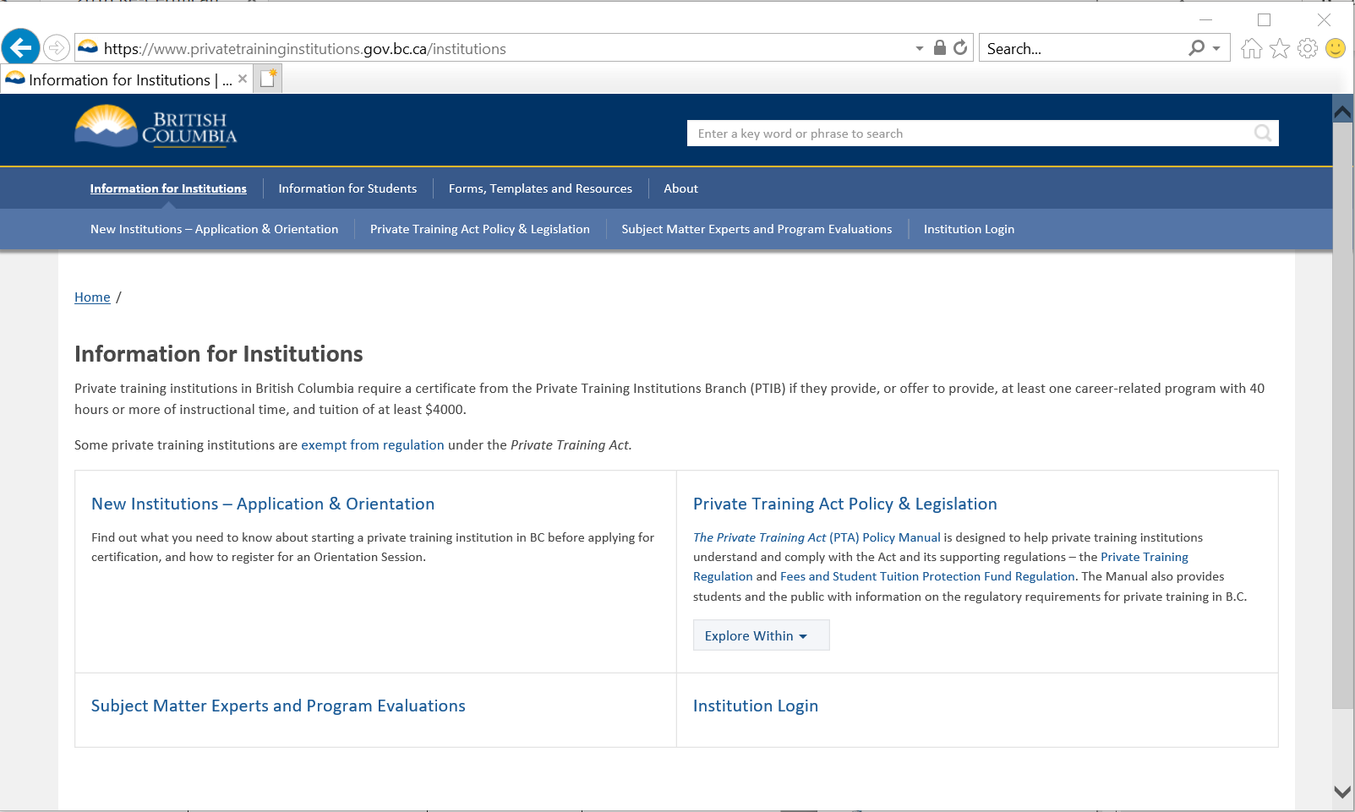

How do I login to the PTI Portal?

A Business BCeID is required to access the portal. A Business BCeID is an online account with a unique user identification and password which provides secure access to online government services. To register for a Business BCeID account, go to https://www.bceid.ca. Once you have created the Business BCeID account, you will need to provide the full name, email address, Portal security role (Administrator or Basic User), and BCeID User ID of the BCeID account holder to PTIB by emailing this information to PTI@gov.bc.ca. This email must be sent from the email account associated with your BCeID account.

There are two types of PTI portal users: Administrators and Basic Users. Administrators can view upcoming due dates, upload documents, manage portal user access, submit and complete a re-certification application, upload student data, and pay invoices:

Basic users can complete and save a re-certification application (but not submit), upload documents, access program information, view program applications status and pay invoices:
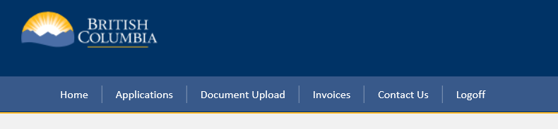

How do I modify the list of users who access the Portal?

The Manage Users section lists the institution’s Business BCeID user accounts, their respective full names and email addresses. To assign a BCeID user to access the Portal as a Basic User, click “Authorize”. To remove the user from access the Portal, click “De-authorize”. Only users with Administrator access can perform this function.
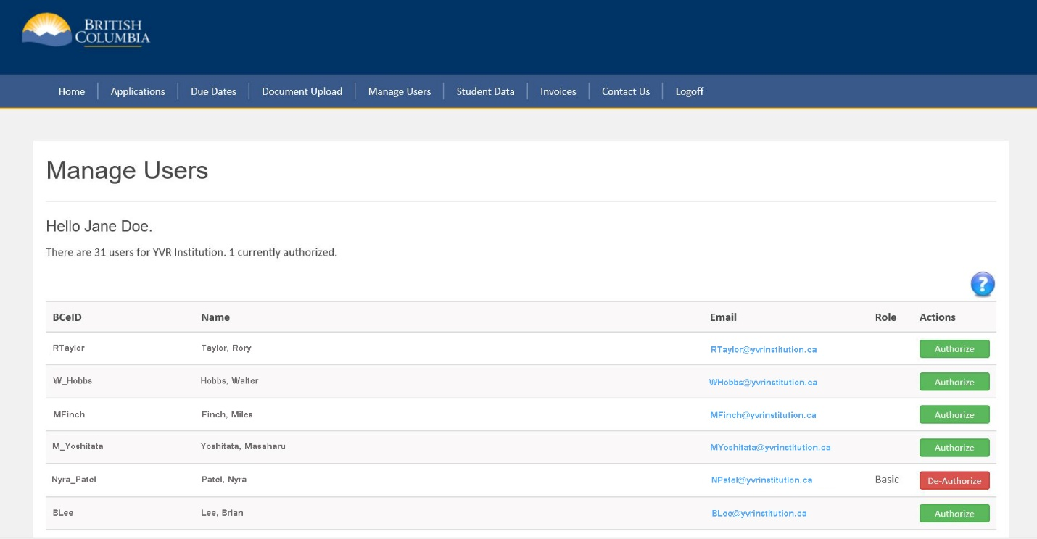
To activate a new or additional user for the Administrator role, you will need to provide the full name, email address, the permission level to be granted (ie. Administrator), and BCeID User ID of the BCeID account holder for your institution by emailing this information to PTI@gov.bc.ca.

Does the Portal provide information related to my institution?
The Portal’s home page lists your institution’s operating name, institution ID, certificate type and the expiry date of the current certificate. You can also view any outstanding invoices and upcoming due dates.
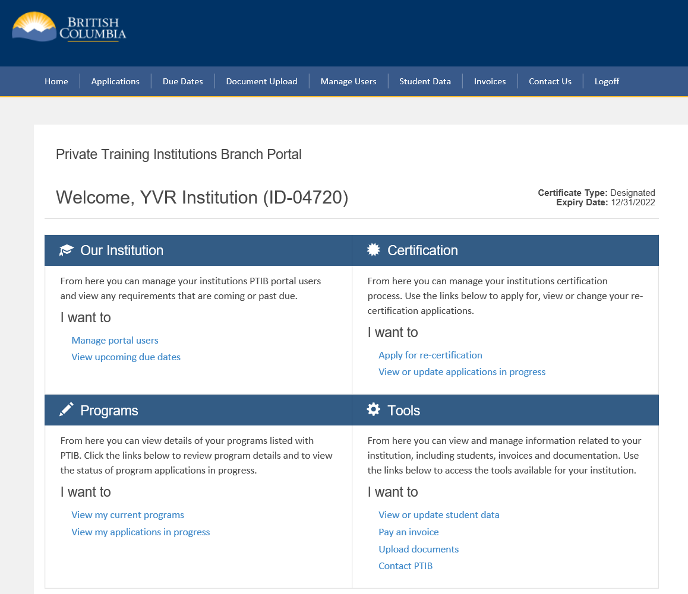

How do I submit a re-certification application via the Portal?
The re-certification application is only available for a certain period prior to the submission due date. It is open for submission after your institution's previous fiscal year end date and prior to the application due date. When it is available, login to the Portal and on the home page, in the Certification section, click "Apply for re-certification.”
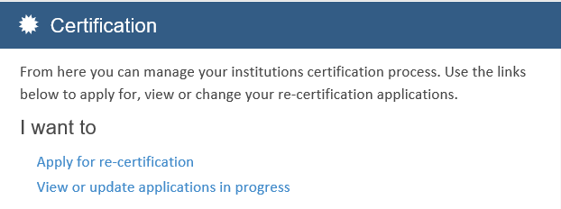
The Re-certification application lists your institution’s current information and the requirements for re-certification. Review the current information and provide the required information.
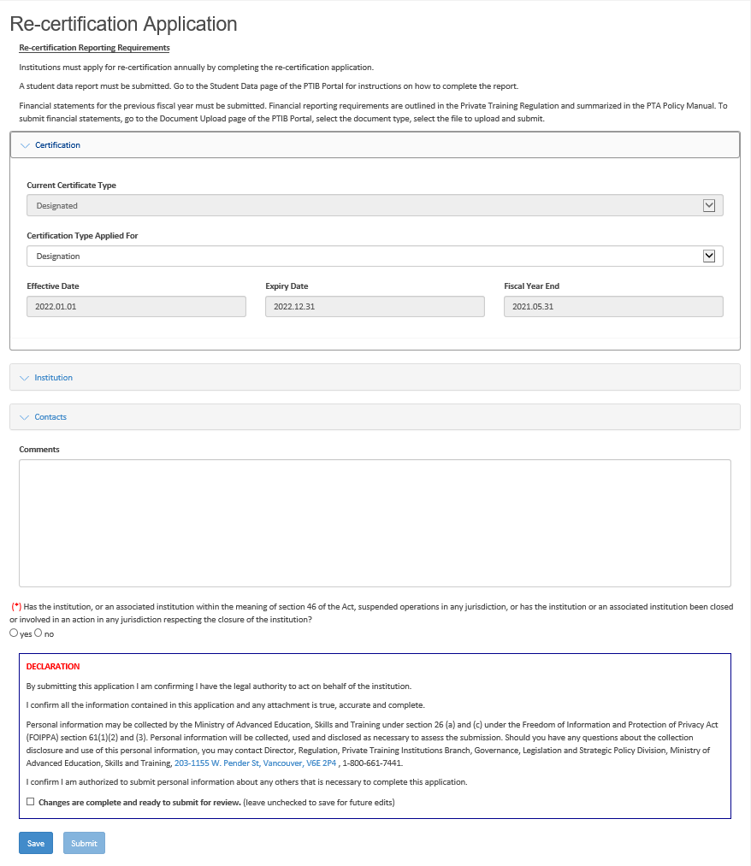
Expand this section
Answer this question
Expand this section
Select the certificate type applied for
Expand the Institution section:
If there’s a change to the operating/legal name, business type or incorporation number (if applicable), contact PTIB

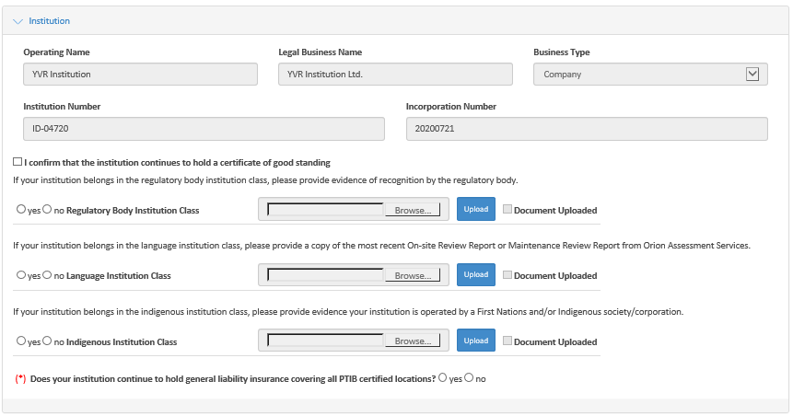
Confirm whether your institution belongs to any of these institution classes. Upload the required supporting document, if applicable.
If your institution is a company or an extra-provincial company, confirm whether your institution is in good standing with BC Registry Services.
Upload the required supporting document, if applicable.

Confirm whether your institution holds valid general liability insurance.

Expand the Contact section:
All PTIB contacts are listed in this section. Review each contact’s information and update the details, if applicable. If there is a change to the contact person’s name but no change to the contact, do not update these fields and instead contact your Regulation Administrator or email PTIB@gov.bc.ca.
Except for first name and last name, update the field by directly entering the information.

To add a new required contact, click the button “Add New Contact” and enter the details.

If the contact is no longer an institution contact, check “Remove”.
Update these fields as needed by directly entering the information in the box. This does not apply to the first and last name.

1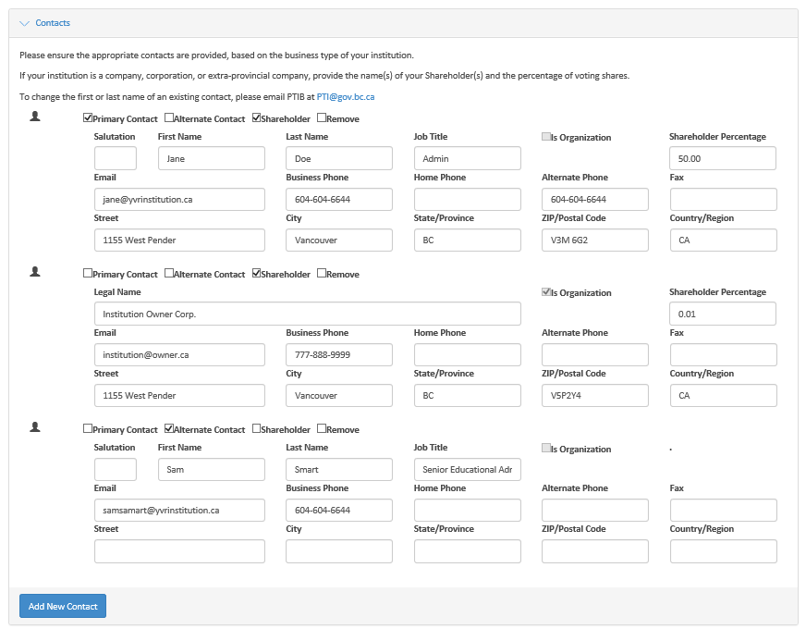

Please note that once the application has been submitted, it cannot be revised; therefore, if you intend to make changes to the application at a later date, save the application before closing and do not submit until it is complete.
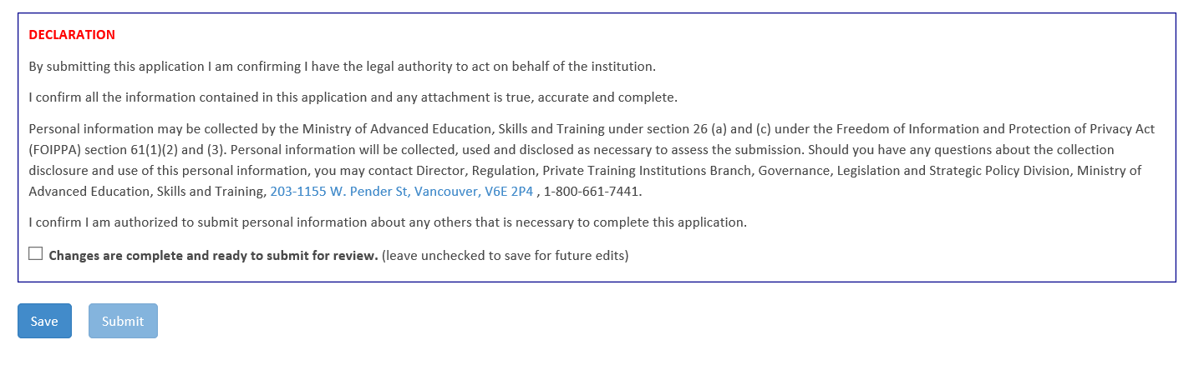
To submit the application, select “Changes are complete and ready to submit for review”, and click the Submit button.
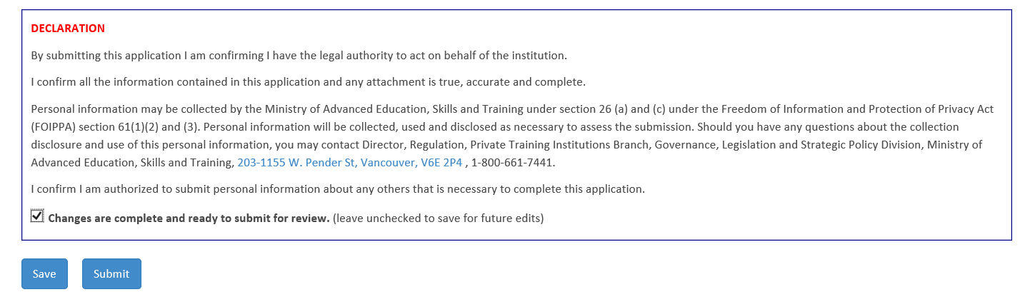
What is a Document of Record (DOR)?
PTIB will acknowledge the receipt of the re-certification application by sending you a copy of the submitted application in PDF format. This document is titled the Document of Record (DOR). All changes you have made in the application will be highlighted in yellow. Please review the DOR carefully. If there is any discrepancy between the changes you have made in the application and the DOR, please contact your Regulation Administrator or email PTI@gov.bc.ca immediately.
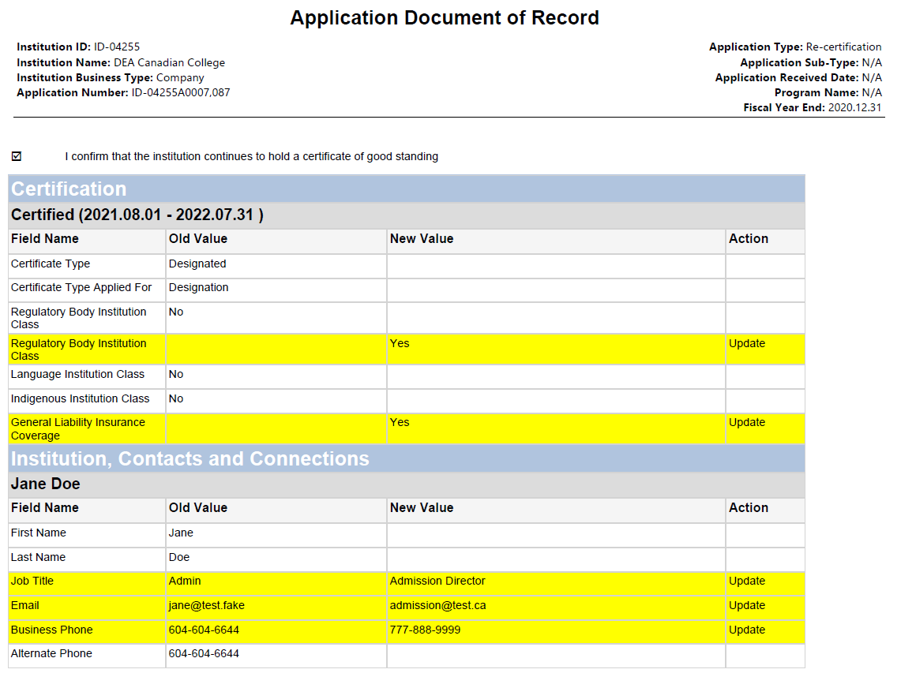
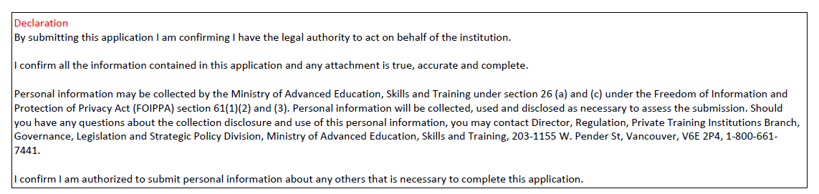
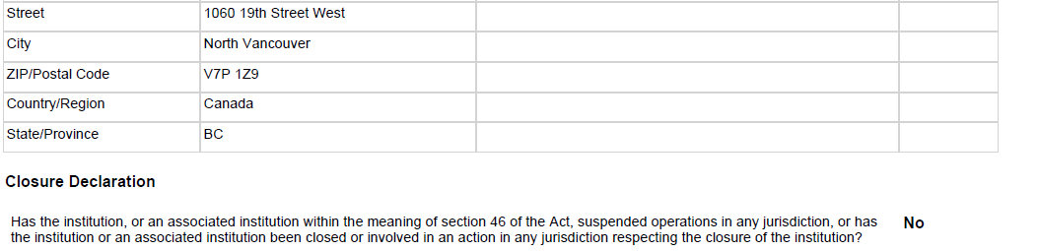

Am I able to access the program information for all the programs my institution has listed with PTIB?
You can view the details of your current programs by clicking the link “View my current programs” under the Programs section:
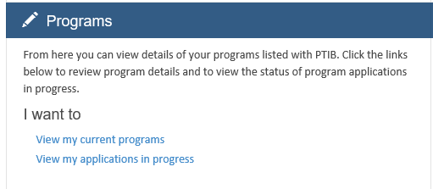

The “View my current programs” page lists all the programs that have been approved or determined by the registrar to be programs that do not require approval. Click to view additional program details.
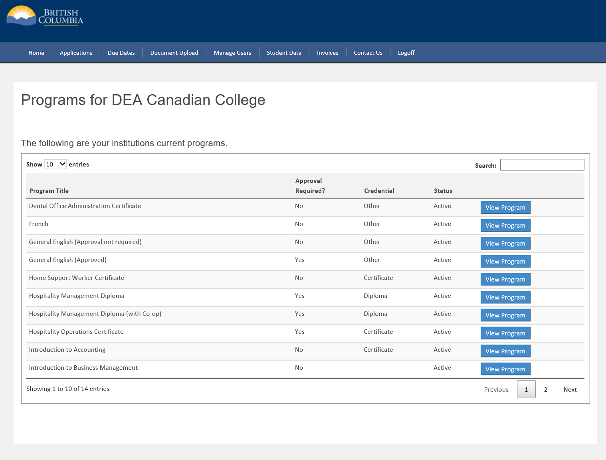

You can view the details of each program by expanding the sections, or clicking the downward arrow in front of each section title:
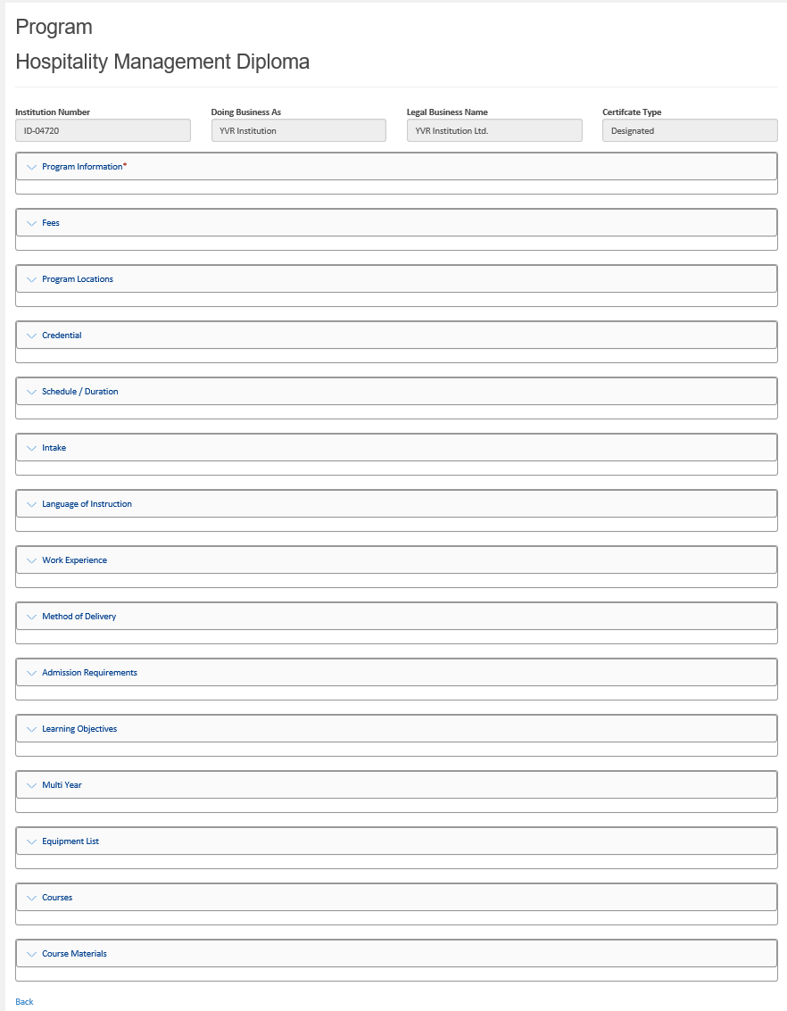

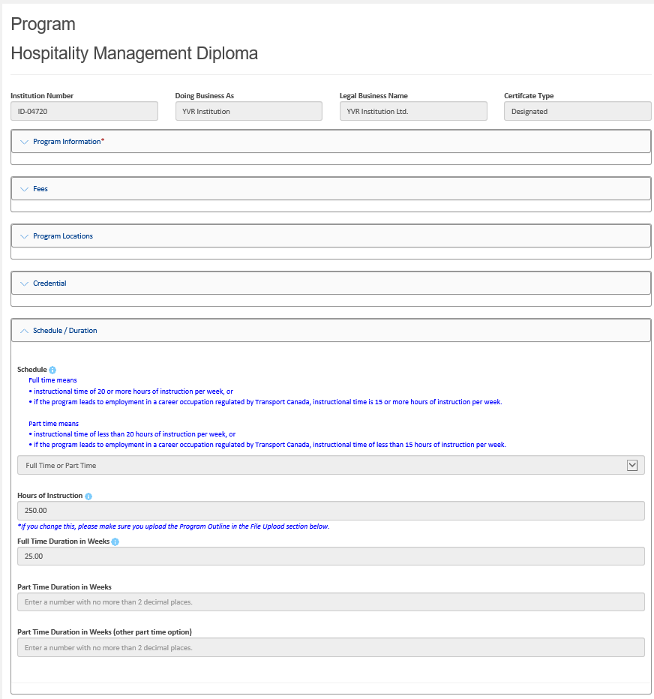

How do I submit a change to the program information?
At this time, you are not able to submit a change to the program information through the Portal. To submit a change to the program, you need to complete an Application – Program Change (DOCX) and email the completed application to PTI@gov.bc.ca. This application form is available on PTIB’s website, under the Forms, Templates and Resources section. In this section, you will also find other application forms such as new program, new location, and institution and contact change forms.

How do I find out the status of my program application?
To find out the status of a new program application or program change application, go to “View my applications in progress” under the Programs section or from the home page, click “Application” from the top menu:
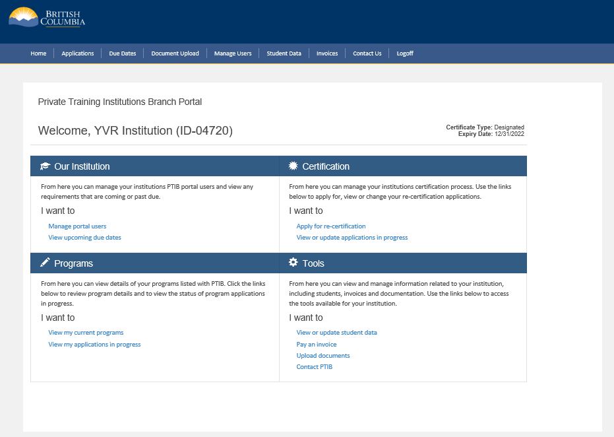

The “View my applications in progress” page lists all the new program applications and program change applications that have been submitted and their current status:
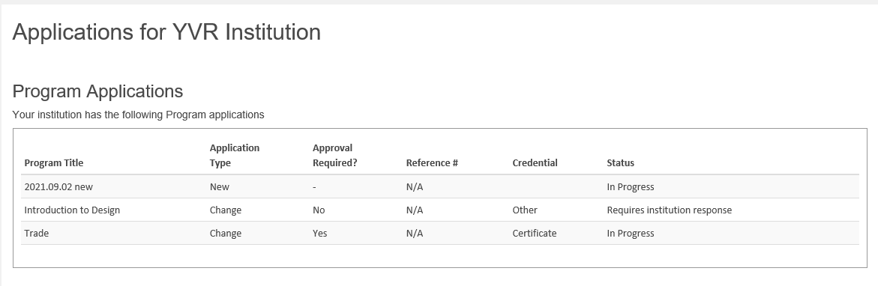

How do I find out about upcoming due dates?
Due Dates
The Due Dates section allows you to check upcoming due dates for requirements such as the next re-certification application, responding to inspection findings, or payment of an outstanding invoice:
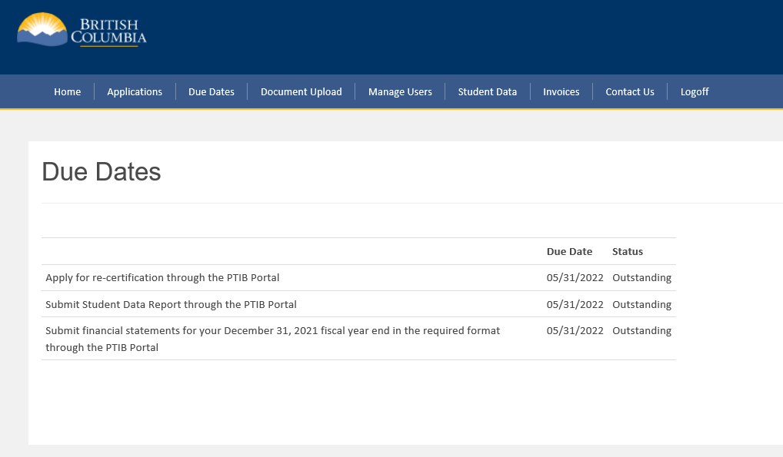

What is Document Upload?
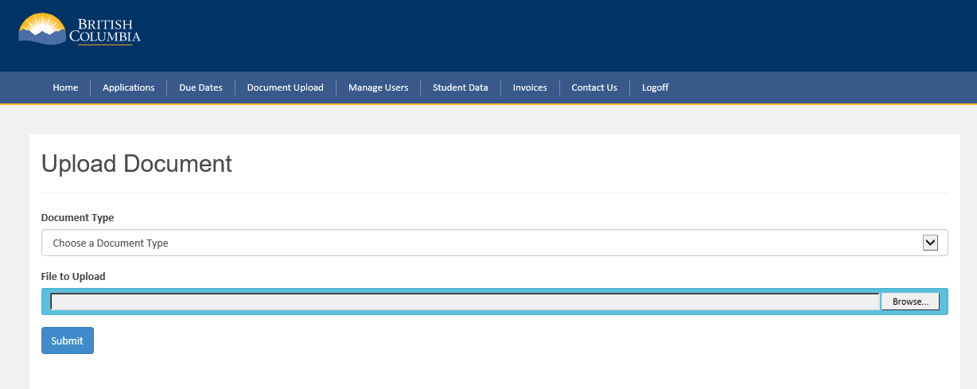
The Document Upload section provides a secure means of submitting documents.

Select one of the document types from the pull down menu: 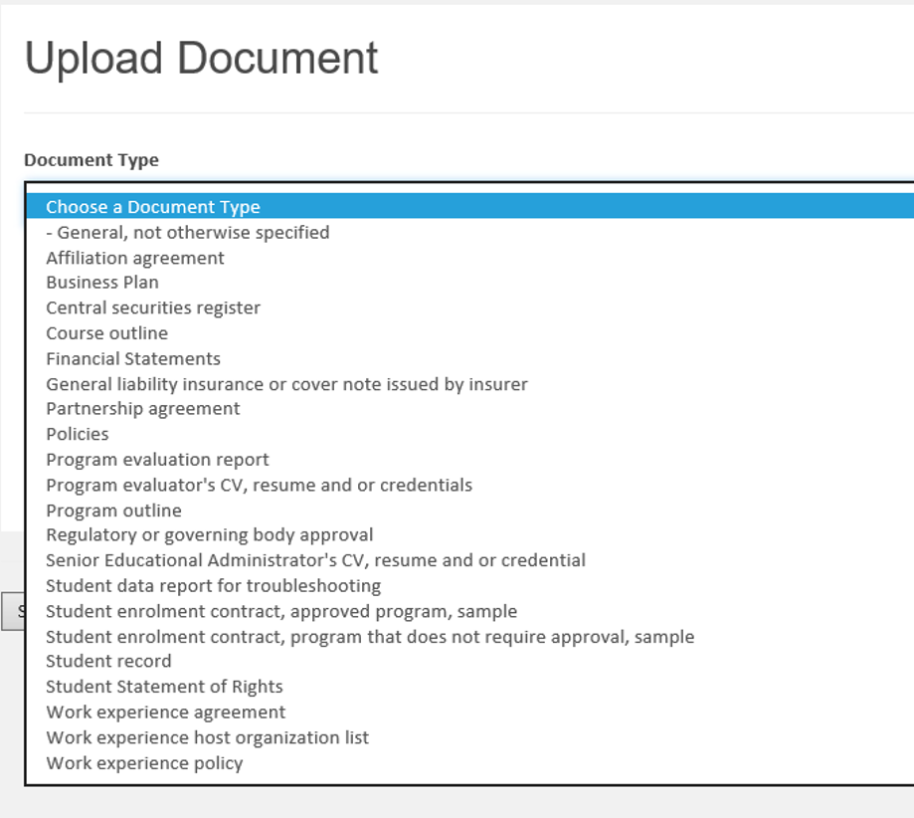
Then browse your local drive and select the file to upload, and click Submit:
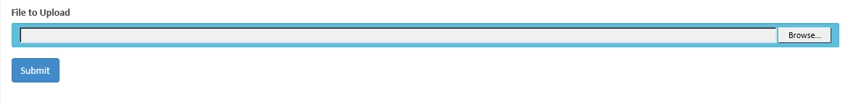
If the document type listed is not available, select “General, not otherwise specified” and send an email to pti@gov.bc.ca to explain the purpose of the upload.
Please note only files of the following types are allowed: doc, docx, pdf, odt, rtf, txt, jpg, tiff, tif, bmp, gif, png, xls, xlsx, csv.

How do I pay an invoice via the Portal?
Invoices
All outstanding invoices are listed in the Invoices section. Certain payments, such as application fees and payment of the annual certificate term fee invoice, can be made via credit card through the Portal. The button is disabled for certification fees which have been set up for payment via monthly pre-authorized debit. Please note the credit card payment function works best with a PC and Internet Explorer. If you are using a MAC computer, please use Chrome or Firefox as Safari may return errors.
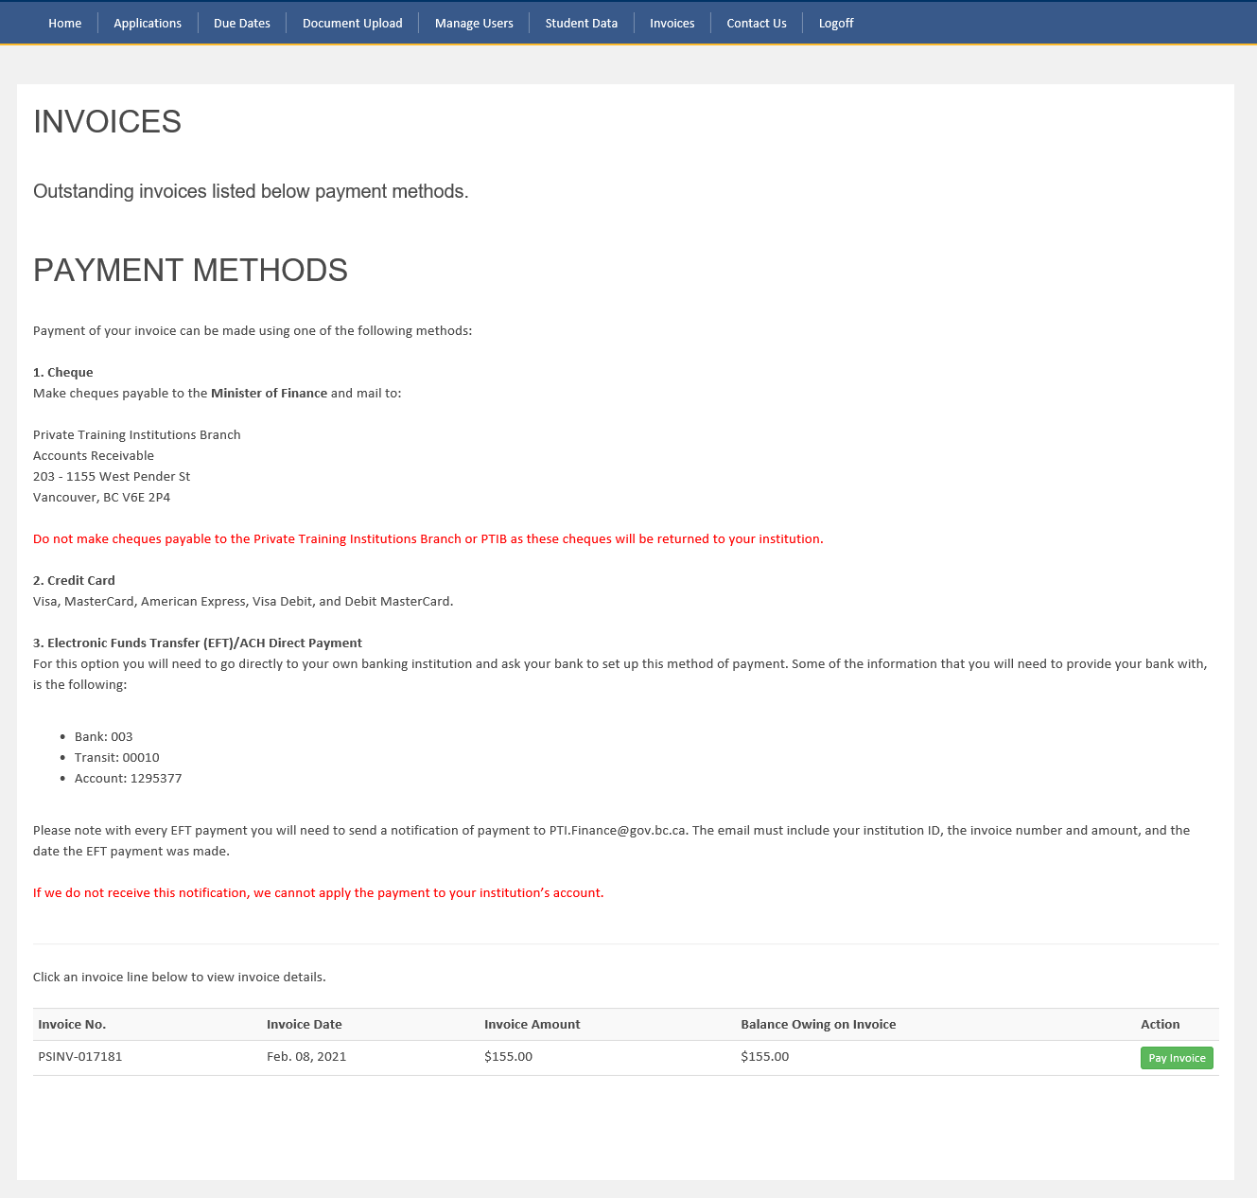

Contact Us
If you receive an error accessing the Portal, please send an email to PTI@gov.bc.ca with a description of what you have tried to do and a screenshot of your browser. Microsoft Windows has a snipping tool that can capture screenshots.
To take a screenshot in MAC, press and hold these three keys: SHIFT-COMMAND-3.
It will help us identify the cause of the issue if a detailed description is provided with a screenshot of the error message. We will then contact you and provide assistance.

Student Data
Please refer to the Student Data Report Reference Guide for information about how to download, complete, and upload a student data report.

